* Launcher System (Technical coherence, requirement engineering) Romane
* Core Stage (Propulsion, mechanical engineering) Valentin
* Booster Stage (Propulsion, separation engineering, mechanism) Bruno
* Recovery System (Software, electrical engineering, mechanism) Noah
* Ground System I/F (Interface management, mechanism, certification) Théo

Main requirements (must be verifiable):

* The vehicle should reach a maximum apogee of 200m
* The main core stage should land under a parachute
* The booster should detach from the center core after their burn
* The propulsion should be only done by water and air

Mission phases - Concept of operation:

* Avionics powers in
* Countdown
* Liftoff
* End of burn of boosters
* Booster separation
* Apogee reached of the center core
* Center core’s parachute deployment
* Landing of the center core

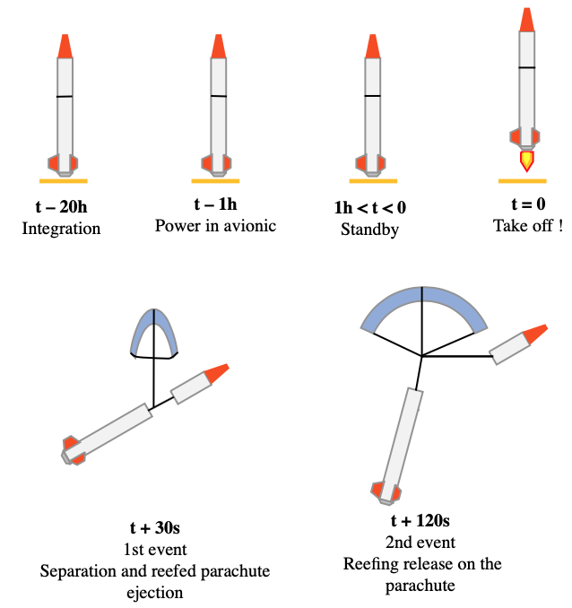 (to update, in progress… )

Verification to be performed

Schedule with short description of main task

08.03.2022 - Organization of the Project (Phase 0)

* Mission characterization
* Mission evaluation
* Requirements Definition
* High level specifications

22.3.2022 - Define Ground I/F

5.4.2022 - Performance Analysis

26.4.2022 -Verification Plan

10.5.2022 - Qualification Review

24.5.2022 - Lift-off